NAME:- MALLIK THANU NAIK

ROLL NUMBER :- 211039038

1ST QUESTION

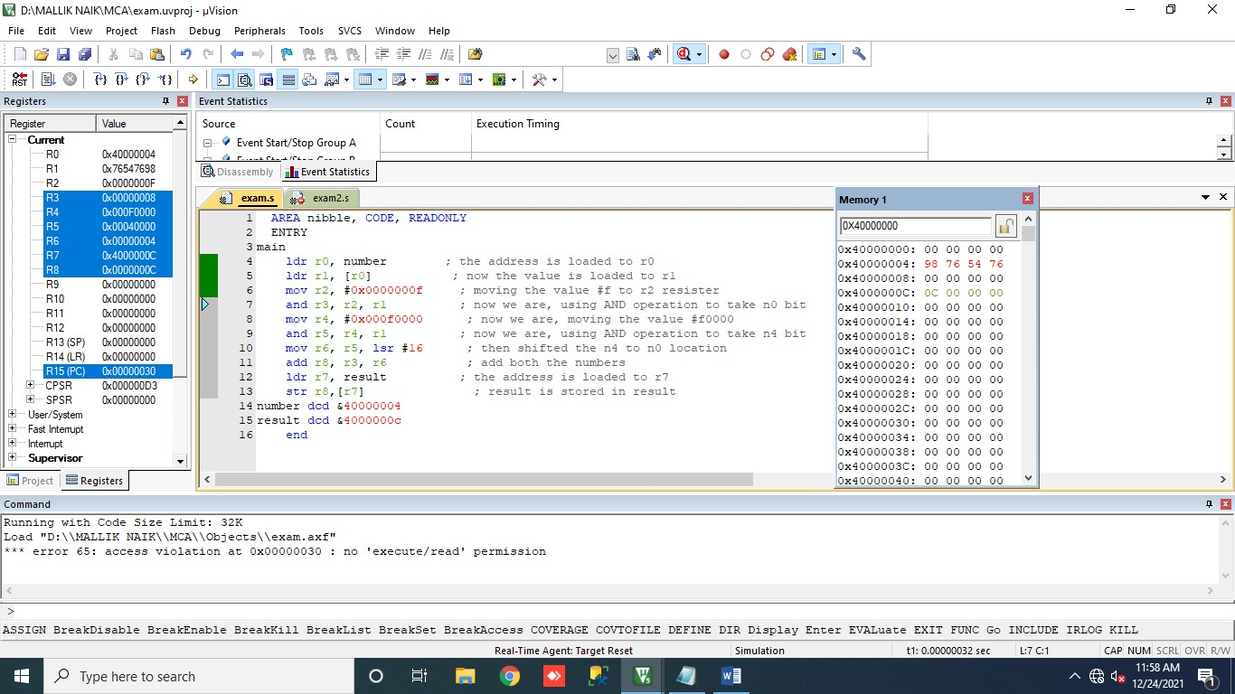

# PROGRAM FOR THE FIRST ONE

AREA nibble, CODE, READONLY ENTRY main

ldr r0, number ; the address is loaded to r0 ldr r1, [r0] ; now the value is loaded to r1 mov r2, #0x0000000f ; moving the value #f to r2 resister and r3, r2, r1 ; now we are, using AND operation to take n0 bit mov r4, #0x000f0000 ; now we are, moving the value #f0000 and r5, r4, r1 ; now we are, using AND operation to take n4 bit mov r6, r5, lsr #16 ; then shifted the n4 to n0 location add r8, r3, r6 ; add both the numbers ldr r7, result ; the address is loaded to r7 str r8,[r7] ; result is stored in result

number dcd &40000004 result dcd &4000000c

end

2ND QUESTION

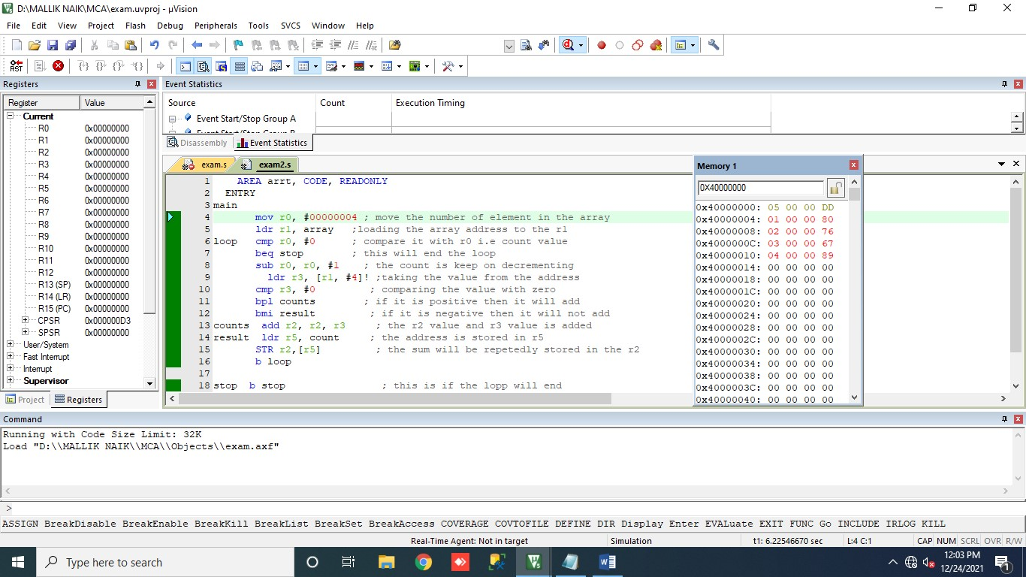

# PROGRAM FOR THE SECOND ONE

AREA arrt, CODE, READONLY ENTRY main mov r0, #00000004 ; move the number of element in the array ldr r1, array ;loading the array address to the r1 loop cmp r0, #0 ; compare it with r0 i.e count value beq stop ; this will end the loop sub r0, r0, #1 ; the count is keep on decrementing ldr r3, [r1, #4]! ;taking the value from the address cmp r3, #0 ; comparing the value with zero bpl counts ; if it is positive then it will add bmi result ; if it is negative then it will not add counts add r2, r2, r3 ; the r2 value and r3 value is added result ldr r5, count ; the address is stored in r5

STR r2,[r5] ; the sum will be repetedly stored in the r2

b loop

stop b stop ; this is if the lopp will end array dcd &40000000

count dcd &40000000

end